Lab 3 Report

Willow Westbrook
Loyola Marymount University
BSAN-6070-02: Intro to Machine Learning

Contact Me:
wwestbro@lion.lmu.edu

Descriptive Analytics on Product Monthly Panel Dataset
In today’s data-driven market, understanding customer preferences and product performance is crucial for businesses to stay competitive. Descriptive analytics provides a foundational approach to uncovering trends, patterns, and insights hidden within large datasets. This report focuses on applying descriptive analytics techniques to the Product Monthly Panel dataset, aiming to explore customer feedback, product ratings, pricing strategies, and user demographics. By analyzing these aspects, the goal is to derive actionable insights that can inform marketing strategies, product development, and customer engagement initiatives.
The dataset consists of 73,272 records with 14 columns, including numerical, categorical, and datetime fields. Numerical columns include rating, is_recommended, helpfulness, total_feedback_count, total_neg_feedback_count, total_pos_feedback_count, and price_usd. Categorical columns consist of product_id, brand_name, skin_tone, eye_color, skin_type, and hair_color, while submission_time serves as the datetime column.
Several columns, like is_recommended, skin_tone, eye_color, and hair_color, had missing values, highlighting gaps in user-provided demographic data.
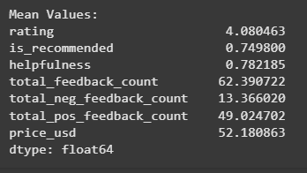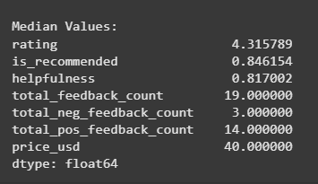
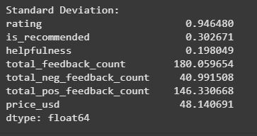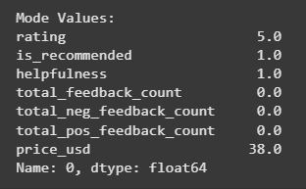
In terms of summary statistics, the mean values show that the average product rating is 4.08, with 75% of users recommending the products and an average helpfulness score of 0.78. The mean total feedback count is 62.39, and the average price is $52.18. The median values indicate a typical product rating of 4.32 and a median price of $40, showing that while some high-priced products exist, most fall into a mid-range price category. The mode values reveal that the most common rating is 5, with many products having zero feedback counts, reflecting the variability in product popularity. The range of values highlights substantial variability, with price ranging from $1 to $1,897 and feedback counts spanning from 0 to 11,975.
The Distribution of Product Ratings shows a right-skewed distribution, with most ratings clustered around 4 and 5, indicating general customer satisfaction.
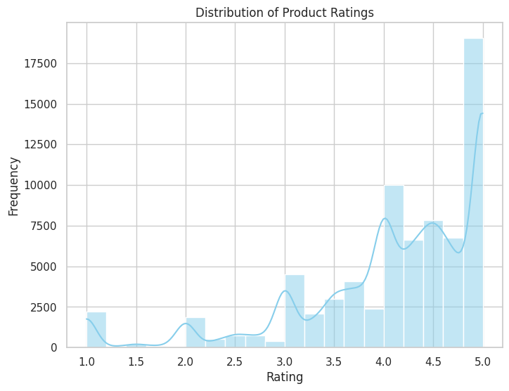
The Price Distribution by Top 10 Brands reveals a wide range of prices, with premium brands like Kate Somerville displaying higher medians, while budget brands like The Ordinary offer lower-priced products.
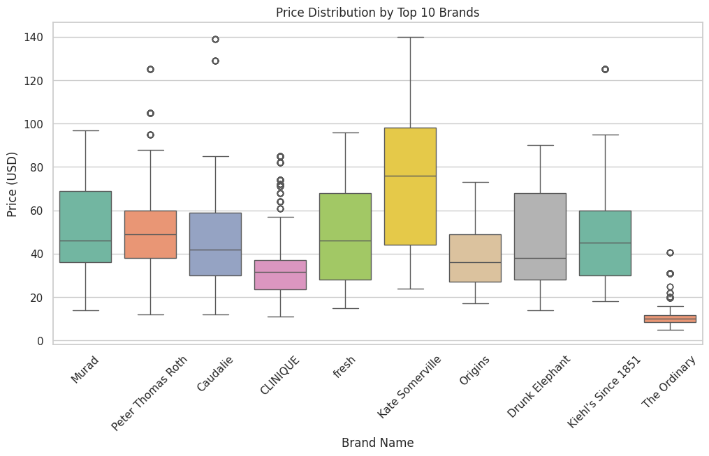
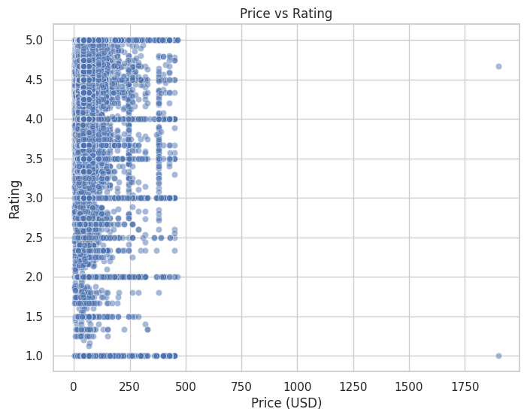
The Price vs Rating Scatter Plot indicates no strong correlation between price and rating, suggesting that higher prices do not guarantee better customer reviews.
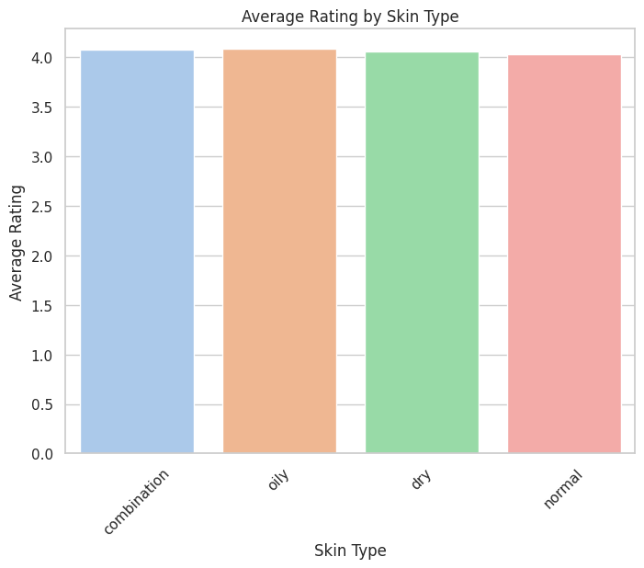
The Average Rating by Skin Type shows consistent ratings across all skin types, averaging around 4.0. The Skin Tone Distribution indicates that most users reported light or fair skin tones, while the Eye Color Distribution shows a dominance of brown eyes among users. These distributions help outline the dominant demographic profiles within the dataset.
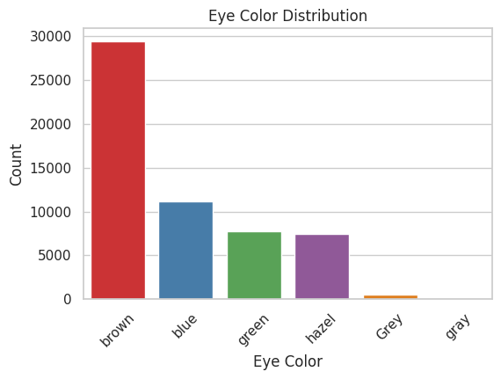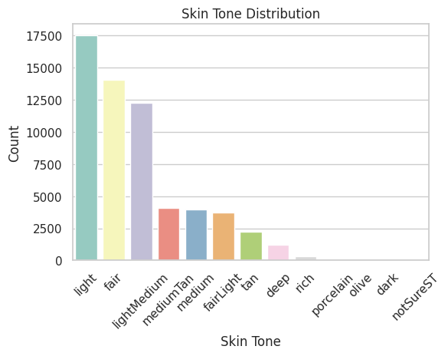

The Correlation Heatmap highlights a strong positive correlation (0.90) between rating and is_recommended, suggesting that higher-rated products are more likely to be recommended. However, there is minimal correlation between price_usd and rating (-0.05), reinforcing the earlier observation that price does not significantly impact customer ratings.
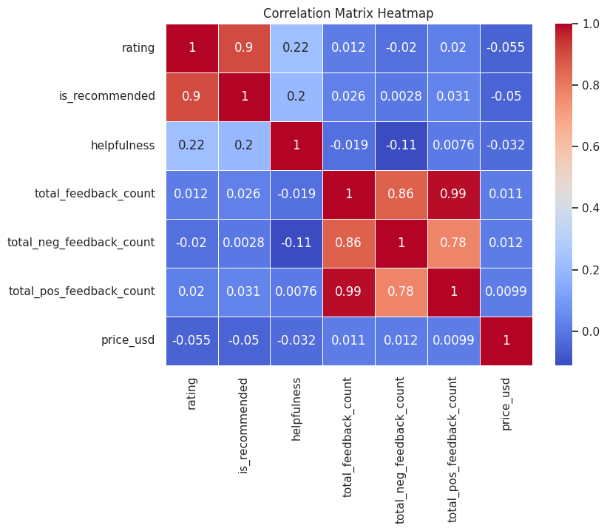
From these analyses, several key insights emerge. Firstly, customer preferences lean towards highly rated products that are frequently recommended, regardless of price. Premium brands do not always receive higher ratings, indicating that brand reputation alone may not influence customer satisfaction. The demographic data suggests that the dataset is skewed towards users with lighter skin tones and brown eyes, which could impact product feedback. Finally, the wide range in feedback counts suggests uneven customer engagement across products.
In conclusion, this descriptive analytics report has provided a comprehensive exploration of product performance, user preferences, and demographic trends within the dataset. The analysis highlighted that while most products receive high ratings and recommendations, price does not significantly influence customer satisfaction. These insights offer a strong foundation for guiding marketing strategies, product development, and targeted promotional efforts.
This lab has positioned me at a pivotal point in my project, equipping me with a deeper understanding of the dataset and setting the stage for more advanced analytical techniques. Moving forward, I plan to transition from descriptive analytics to predictive modeling, focusing on forecasting product ratings based on key features. Additionally, conducting sentiment analysis on user reviews will offer richer, qualitative insights into customer opinions and behaviors. Addressing existing data gaps, particularly missing demographic fields, will also be a priority to improve the robustness and precision of future analyses.

